Proceedings of IMEC 2019

International Mechanical Engineering Congress (IMEC-2019),

29th November- 1st December 2019, NIT Tiruchirappalli, India.

IMEC2019-xx-xxxx

**Title**

Author1a*, Author2b,

a Department of Mechanical Engineering, NIT Trichy

b Department of Mechanical Engineering, NUS Singapore

* Corresponding author email: vedha@nitt.edu

**ABSTRACT**

In this paper, variation of cutting forces and corresponding torque exerted on tool with respect to cutting parameters for ball end milling process is analysed using deep neural network. A neural network was fabricated to predict cutting force and torque values for a given set of cutting parameters. Analysis was done by varying axial depth of cut and feedrate while keeping all other parameters constant, because the variation of cutting forces and torque was most significant for these two parameters. For generating data CutPro simulation software was used along with AutoIT to automatically vary the parameters and simulate. Finally, after proper tuning of hyperparameters of the neural network, maximum percent deviation of predicted values over test dataset was brought down to less than 5 percent.

**INTRODUCTION**

Machining is the most widespread metal shaping process in mechanical manufacturing industry. Machining is a subtractive process where a raw material is turned into a desired product by removing the material around it. The study of forces generated during machining, Workpiece and tool material, tool and workpiece geometry, machine parameter settings influence the process efficiency and output quality.

Titanium alloys find a wide application field in many industries, especially in space, aviation, biomedical, automotive and oil industries, due to high strength-weight ratio, superior corrosion resistance, low young modulus and biocompatibility properties of these materials. About 70% by weight of titanium-based alloys are used in the aero-space industry [1]. Ti-6Al-4V alloy was specifically developed for applications demanding exceptional mechanical and chemical properties at elevated temperatures. Ti-6Al-4V alloy is particularly known to exhibit high strength to density ratios and good corrosion resistance properties. Titanium alloy is difficult to machine due to high chemical reactivity, generation of high cutting forces during milling, low thermal conductivity, high rigidity.

Many researchers have given their insights in understanding machining of Titanium alloy and effects of cutting parameters on the cutting forces. Rashid et al [1] conducted the research on T-6Cr-5Mo-5V-4Al beta aluminium alloy using Laser-assisted Machining [LAM]. The findings revealed that LAM significantly reduced cutting force within a certain range of cutting parameters. Niu et al [2] found that resultant cutting force increased with cutting speed in face milling process of TC6 alloy. Szymon Wojiciechowski et al [3] proposed a cutting force model for ball end mill for finishing operation which includes influence of surface inclination and cutter runout. Research revealed that cutter's run out and surface inclination angle have significant influence on the cutting forces, both in the quantitative and qualitative aspect. S.Sun et al, M.Brandt et al, M.S Dargusch et al [4] observed chip formation with dynamic cutting force measurements under different cutting speeds, feed rates, and depth of cuts. Both segmented and continuous chip formation of one cut at larger feed rates and lower cutting speeds were observed. A cyclic force produced during formation of segmented chips and the force frequency was the same as the chip segmented frequency. The peak of the cyclic force when producing segmented chips was 1.18 times that producing the continuous chip. The cyclic force frequency increased linearly with cutting speed and decreased inversely with feed rate. The cutting force increased with the feed rate and depth of cut at constant cutting speed due to the large volume of material being removed. n cutting force with increasing cutting speed was attributed to the strain rate hardening at low and high strain rates, respectively. The decrease in cutting force with increasing cutting speed outside these speed ranges was due to the thermal softening of the material.

**DATA GENERATION**

Axial Depth of Cut [ADOC] was varied from 1mm to 1.9mm in the steps of 0.02mm and Feedrate was varied from 0.200 mm/flute to 0.290 mm/flute in steps 0.01 mm/flute.

Ti-6Al-4V machining simulation was carried out on CUT-PRO simulation software. A 4-Flute Ball. End Mill tool with constant helix was chosen for slotting operation

|  |  |
| --- | --- |
| **Parameter** | **Value** |
| Diameter | 20 mm |
| Length | 150 mm |
| Flute Height | 10 mm |
| Helix Angle | 300 |
| Rake Angle | 50 |

**Workpiece used was Ti-6Al-4V with following properties**

|  |  |
| --- | --- |
| **Property** | **Value** |
| Hardness | 340HB |
| Density | 4.706g/cm3 |
| Thermal Conductivity | 6.000W/m-K |
| Young’s Modulus | 1.15*1011 N/m2 |
| Tensile Strength | 9*108 N/m2 |
| Yield Strength | 8.30 *108 N/m2 |

For various Combination of Feed rate and ADOC, time domain simulations were conducted and instantaneous forces (Feed, Axial, Normal) and instantaneous torque values were stored in excel Files. A total of 600 files were generated for various

combinations of cutting parameters. RMS values for Feed Force, Normal Force, Axial Force and Instantaneous torque were calculated and the findings were plotted on a Pivot Chart.

**CUTTING CONDITIONS CONSIDERED NOMENCLATURE**

|  |  |
| --- | --- |
| **Symbol** | **Description** |
| ‘a’  ‘ft’  ‘hj(ϕj(z))’  ‘db’  ‘dz’ | Depth of cut [mm]  Feed/Tooth  Instantaneous chip thickness at immersion angle(ϕj) [mm]  Chip Width [mm]  Differential ADOC [mm] |

|  |  |
| --- | --- |
| **Parameter** | **Value** |
| Spindle Direction | Clockwise |
| Milling Mode | Slotting |
| Feed rate | 0.200-0.290 mm/flute in step 0.01 |
| Axial Depth of cut  [ADOC] | 1-1.9 mm in step 0.01 |
| RPM | 300-2800 in step 500 |
| Number of Revolution of | 1 |
| Sampling Frequency | 10 |

**Defining Input Parameters**

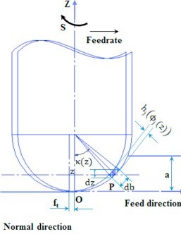 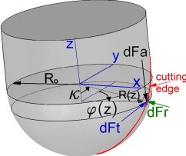

Fig:2 Local Cutting Force of a ball end mill tool

Fig:1 Ball end mill Parameters

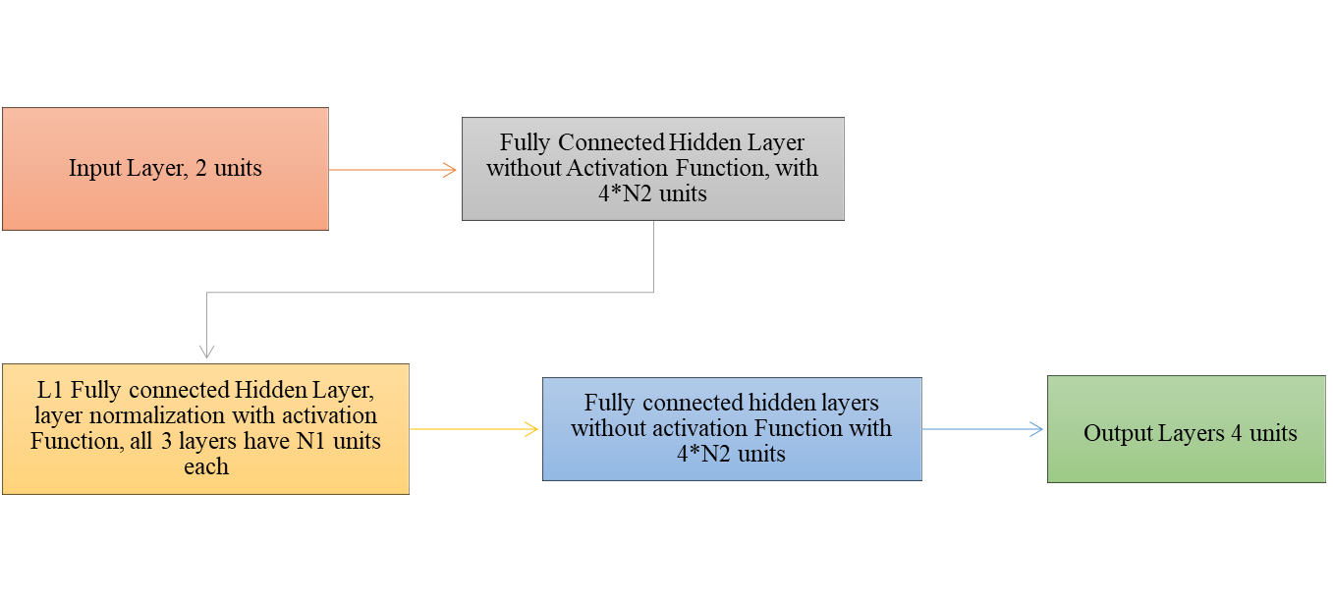

**Training the Model**

**Result and Discussions**

Pivot Charts were plotted to measure RMS forces against cutting parameters ADOC, RPM

and sum of RMS(Axial) Sum of RMS(Normal), Sum of RMS(Feed) Forces.